

Market Twin Beta Testing Guide
  - Beta Tester Onboarding Manual
Mr.AI Inc. (주식회사 미스터에이아이)
Beta v1.0 · June 2026

Welcome to the Beta 3
What is this product? 3
What you’ll do in the beta 3
Beta benefits & limits 3
What’s included 3
Getting Started in 5 Minutes 4
Creating Your First Simulation (6 steps) 5
Reading Your Results 8
Beta Feedback — This Matters Most 🙏 10
Things to Know During Beta 11
FAQ (Beta) 12
Contact & Support 13

Welcome to the Beta
Thank you for joining the Market Twin beta. Your hands-on experience and honest feedback are the single biggest help in refining the product before its full launch.

What is this product?
Market Twin lets you validate an overseas launch before you ship. AI personas — modeled on government statistics for each candidate country’s local consumers — react to your product and pricing, and you get a market simulation in just a few minutes. It answers “which country first, at what price, and how” with data.

What you’ll do in the beta
Run a simulation with a real product you want to validate (or the sample demo), and tell us whether the result is actually useful for a decision. That’s the heart of the beta.

Beta benefits & limits
Item | Detail
Cost | Free (no credit card)
Period | 7 days after signup
Validation runs | 2 hypothesis simulations (real product runs)
Sample demo | 3 per day (separate, not counted against your runs)
Languages | English / Korean

What’s included
- ✅ The full market simulation — success score, multi-country comparison, personas, pricing, decision economics, risks, recommended actions, PDF reports
- 🔒 The Mr.AI marketing-automation module is not part of this beta (we’re focused on simulation validation)

Getting Started in 5 Minutes
- Open app.markettwin.ai in your browser
- Sign up with Continue with Google or email/password
- (Email signup) Click the link in the confirmation email from noreply@markettwin.ai → you’re logged in automatically
  - No email? Check spam, then use “Resend confirmation email” on the screen (60-second interval)
- Once in, the Dashboard is your home screen. Start with + New Project at the top right.
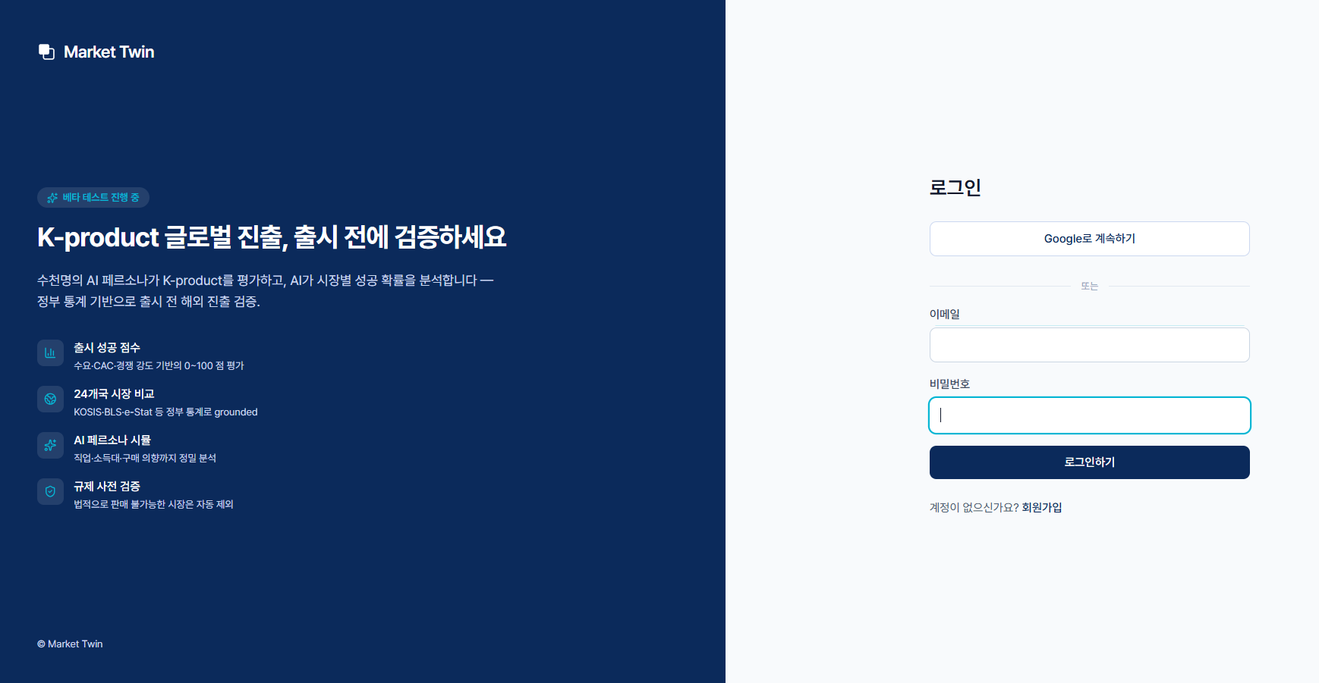
Login / product intro screen
Tip: New here? Skip the input and explore the results screen first with the sample demo (3/day). It doesn’t use up your validation runs.

Creating Your First Simulation (6 steps)
Enter your product over six steps: 1 Product → 2 Price & Goal → 3 Target Markets → 4 Competitors → 5 Creative → 6 Review & Run. Steps 4 and 5 are optional and can be left blank.
Step | Key inputs
1. Product | Product name · category · description (10+ chars)
2. Price & Goal | Base price + currency · launch goal (awareness/instant sales/retention/new market)
3. Target markets | Candidate countries (~5 recommended)
4. Competitors (optional) | Competitor names — AI finds URLs and discovers more
5. Creative (optional) | Ad concepts / mockup images — vision-AI analysis
6. Review & Run | Confirm and run
⚠️ Important — input caution: Do not put market figures like “40% of sales in the US” into the product description. The simulation will take that at face value and skew the result (e.g. auto-recommending the US). Describe only the product itself for a more reliable recommendation. — If this tripped you up during the beta, please tell us.
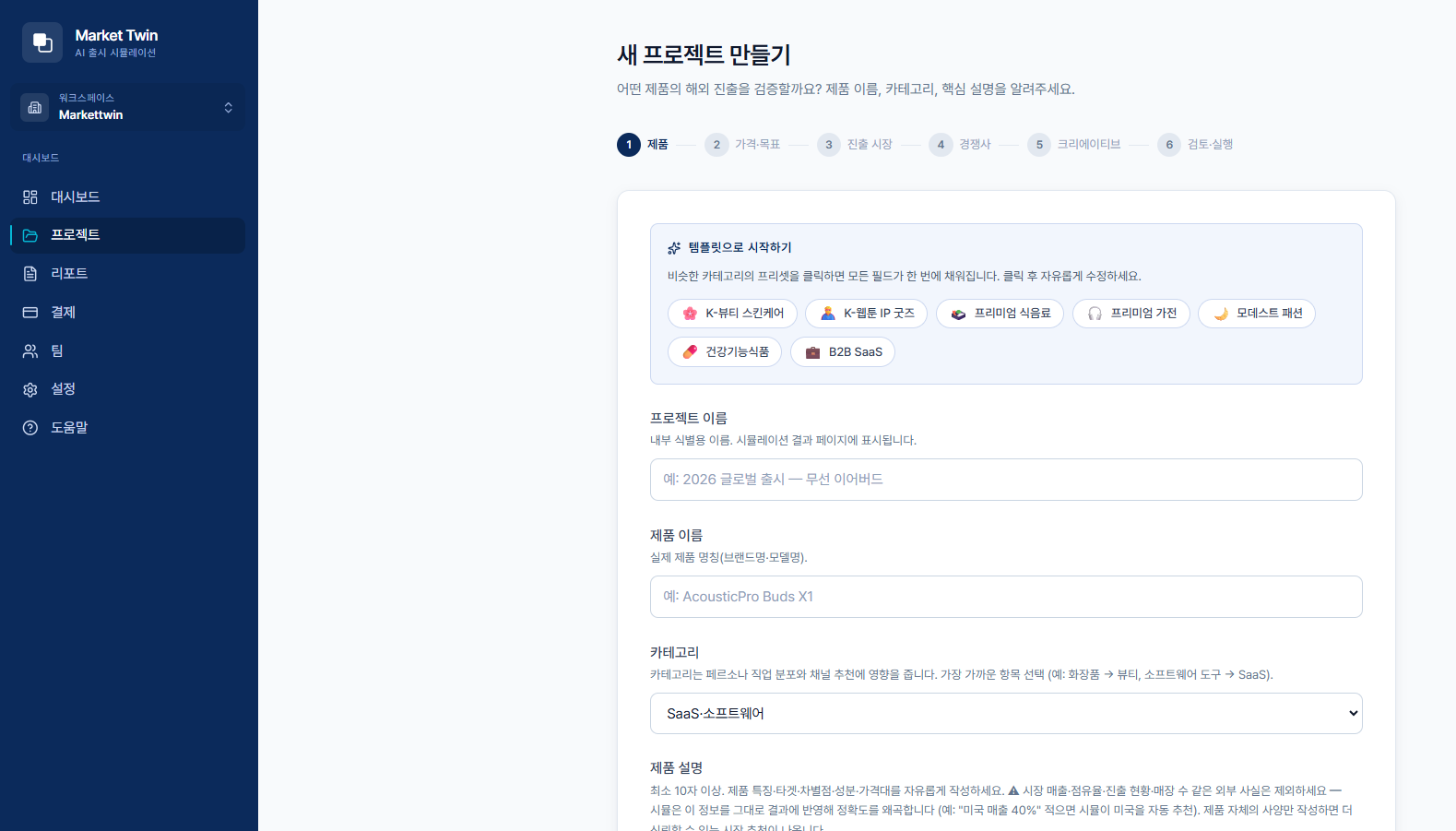
Step 1 — product details
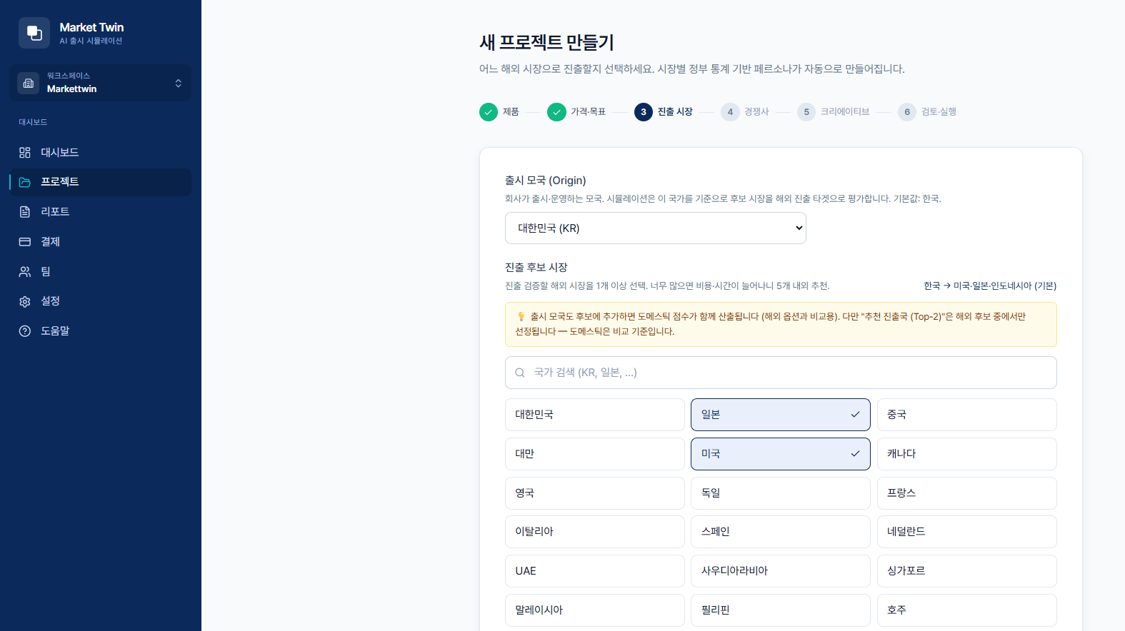
Step 3 — target market selection
When you run it, hundreds to thousands of AI personas start simulating across multiple LLMs. You can close the screen — it keeps running, and usually finishes in a few minutes.
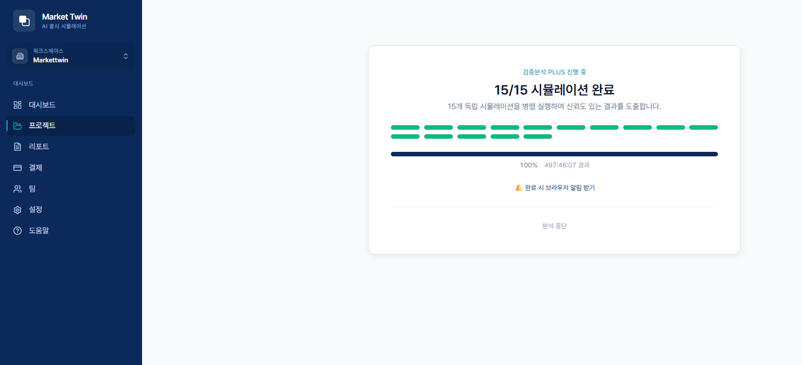
Simulation in progress / complete

Reading Your Results
Results are organized into 10 tabs (Summary · Overview · Countries · Market Analysis · Personas · Pricing · Decision · Risk · Actions · Data). For a first look, these four cover the essentials.
- Personas — purchase-intent distribution and positive/negative voices (first-person quotes)
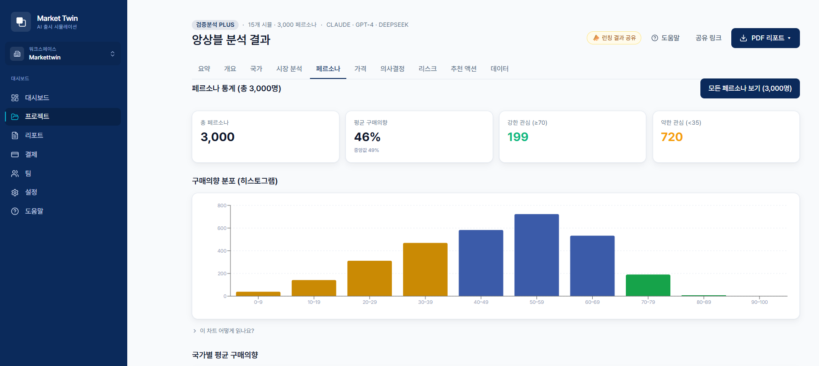
Results — persona analysis
- Pricing — recommended price vs. your input, revenue-maximizing point
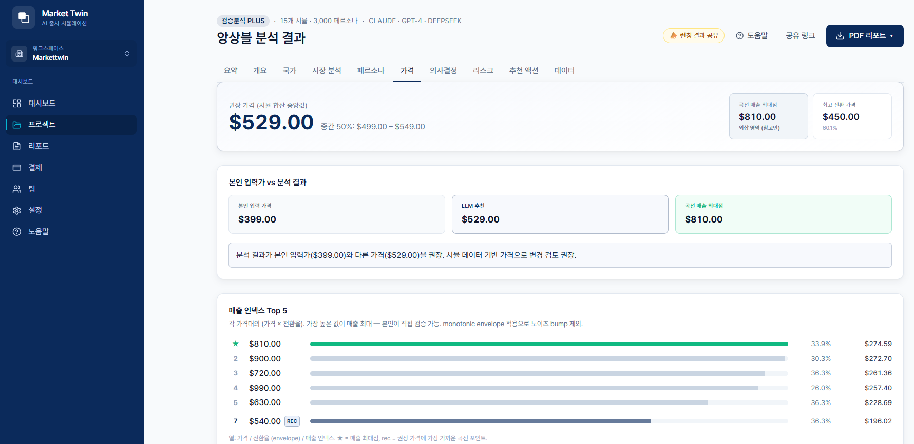
Results — price optimization
- Decision — CAC, expected revenue, break-even scenarios
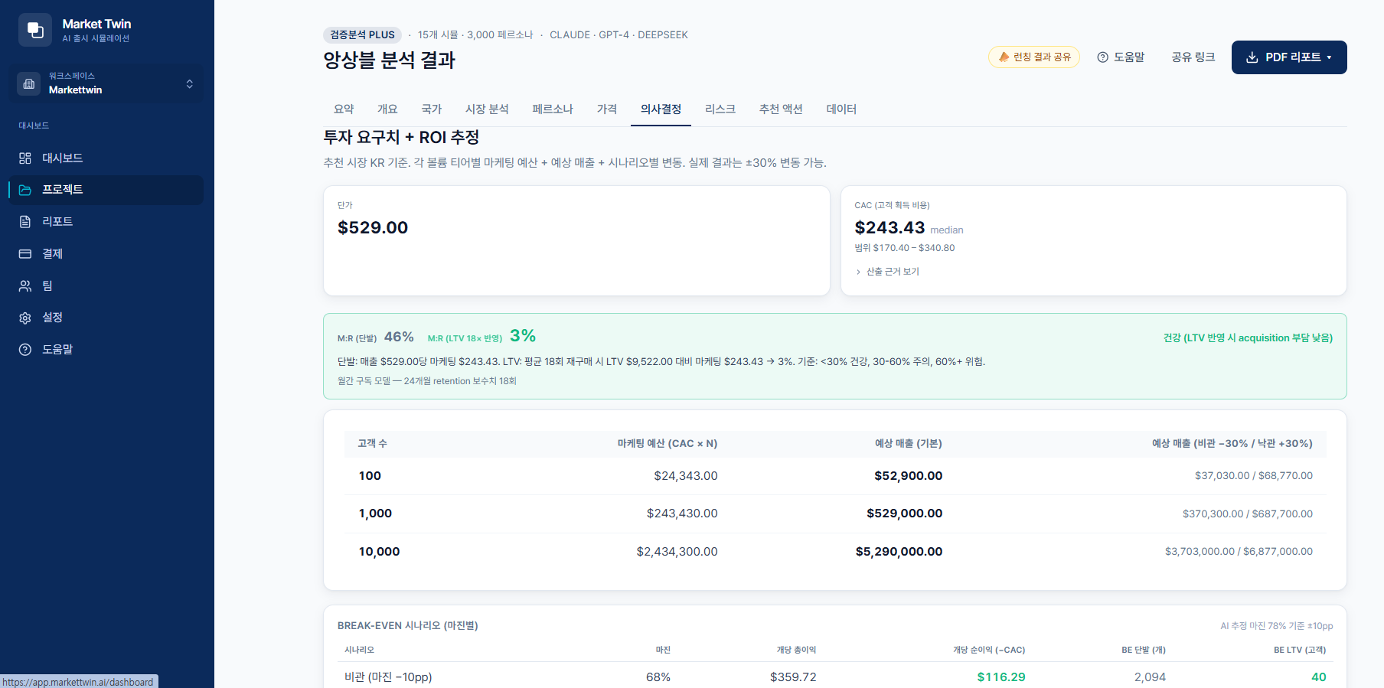
Results — investment / ROI decision
- Actions — impact × difficulty priority (start top-left with Quick Wins)
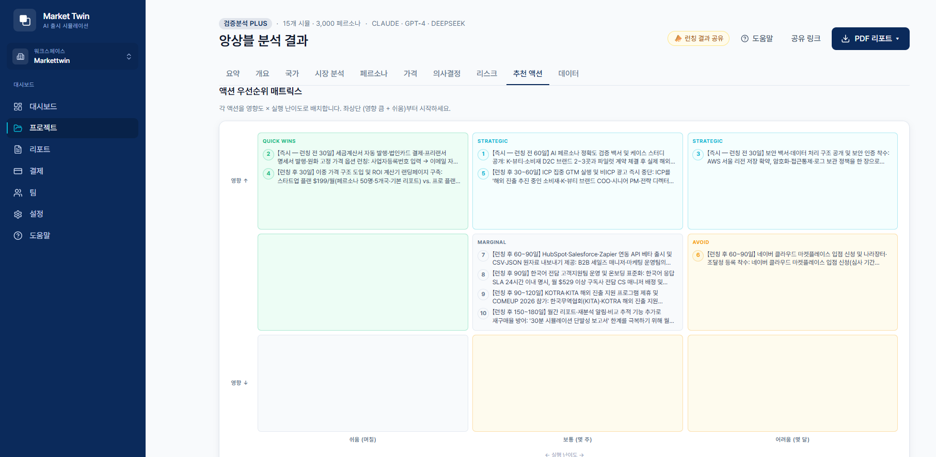
Results — recommended action matrix
Use PDF Report at the top right of the results screen to download three formats: executive, full analysis, and cross-validation.

Beta Feedback — This Matters Most 🙏
At the bottom of the results screen there’s a short survey — “Was this result useful for your decision?” with a 1–5 rating + one-line comment. Please leave it every time you run a simulation. It takes 30 seconds.
These points especially help us:
- Does the recommended country make sense to you? (and why)
- Are the pricing, risks, and recommended actions actually usable?
- Anything confusing or awkward during input?
- How was the speed of getting results?
- Any “I wish it had…” feature
For anything beyond the survey, email us anytime at contact@markettwin.ai.
You can also leave open feedback (anonymously, no login) at the bottom of app.markettwin.ai/beta.

Things to Know During Beta
- Result variability: We ensemble several independent simulations, so the same input can produce slightly different numbers each run (shown with a confidence grade).
- Per-country data variance: Accuracy is higher for countries with richer statistics.
- Data handling: To run the simulation, your input is sent to overseas LLM providers (per the cross-border transfer consent at signup). Payment card details are never stored.
- Results are saved: Closing the screen doesn’t lose results — find them again under Projects/Reports.
- Mr.AI not included: The marketing-automation module is out of scope for this beta.

FAQ (Beta)
Q. What happens when I use up the free limit? Once you’ve used the beta period (7 days) or both hypothesis runs, validation runs are paused. Need more? Let us know at contact@markettwin.ai.
Q. Does the sample demo count against my runs? No. The demo (3/day) is separate from your 2 hypothesis runs.
Q. How long do results take? The sample demo takes 2–3 minutes; a real product validation usually a few minutes. It keeps running even if you close the screen.
Q. Can my team view it together? Yes. Use the result share link, or invite teammates to your workspace.
Q. I found a bug. Thank you 🙇 Send a screenshot to contact@markettwin.ai and we’ll look into it quickly.

Contact & Support
- Email: contact@markettwin.ai
- Operated by: Mr.AI Inc. (주식회사 미스터에이아이)
Any error, friction, or idea you find during the beta is welcome — a single line from you can change the product. Thank you for being here.

Screens in this guide may differ slightly as the beta evolves. © 2026 Mr.AI Inc.

